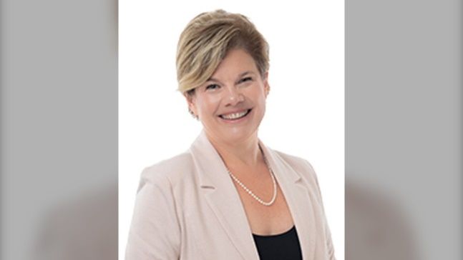

Hoss, great work on Resident Quality Inspection results from Ministry of Health. I am so proud of your work with the team, what a transformation. When I hear of these significant improvements, I am reminded of the personal commitment you role model every day to make this happen. It is not easy to manage LTC. Resolving the compliance issues at this location is something you should be very proud of. Well Done!

Joanne Dykeman- Executive Vice President of Operation,

Sienna Senior Living, Canada

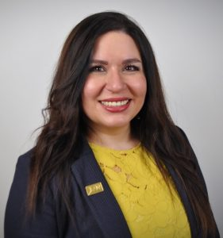

Hoss is a dynamic, compassionate, intelligent, politically astute, and transformational health care leader trusted and respected by our sector. I feel fortunate to know Hoss and to be continuously inspired by him to improve quality of care and services within my teams and organizations.

Bahar Karimi, BScN, MHSc, PhD Long-Term Care Home Executive Director, Canada

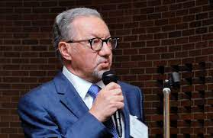

This is to reflect on my experiences working with Mr. Hoss Notarkesh in his capacity as an advisor and consultant in the retirement homes industry. I have known him for more than two years when seeking advice on feasibility and designing a retirement home in one of our properties on Sheppard Ave East, in Toronto. I found Hoss an ethical and professional gentleman, who delivers on time when promises anything. He is very knowledgeable in his field, and is an effective, efficient, and eloquent communicator.

I have no reservation recommending him for any role in feasibility study, management of developments, and operation of retirement residences, or other active operating businesses.

Arsalan MohajerPhD., D.I.C., P.Geo President Nedmar Enterprises Inc. Chairman, Central

Montessori Schools



Hoss has assembled an enthusiastic team and they thrived under his leadership. Hoss transformational leadership style made a great progress in operation and as a result the team delivered the all-time company record of: Strongest year to date growth in Canada +19 and Exceeding 365 day high by +4 (companywide)

Anne Pinter-Executive Vice President of Operation Atria Louisville, Kentucky, USA



Thank you very much for the strategic life/business coaching. You are the most personable and competence coach, who listens to the client and takes the time to discuss every detail extensively. During all sessions, I felt completely at ease and well cared. I strongly praise your professionalism and performance in the highest possible terms!

Mr. Notarkesh helped me in six coaching sessions to improve drastically in a way that that I have never experienced in my previous coaching. It is extremely important to be guided by a competent coach, who can help you to get the complex issues into the key points and address them in a way in which they can be processed effectively. I have made progress and I thank you for that.

Mojgan Heuberger

Founder and Dipl. Eng. Architecture & designer at HEUBERGER **INTERIOR**

Bremen & Palma de Mallorca , Germany, 2020

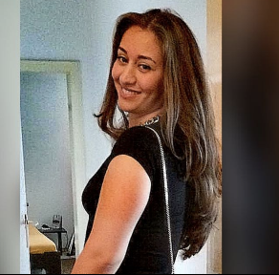

The meetings with Mr. Notarkesh have been great. He is so full of energy and commitment for his work. His professional way makes the communication quite easy. You can tell that he turned his passion into a profession.  
Thank you for helping me to maximize my potential.

Sanaz Larki

Medical and Dental Student from Germany

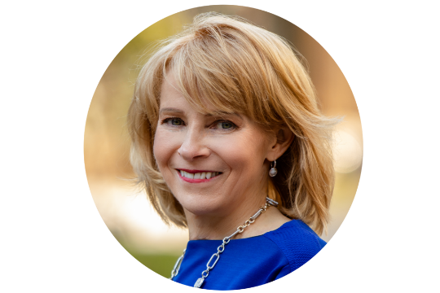

Hoss, I am writing to personally congratulate you on your recent appointment to Senior Executive Director. We very much value having your expertise and passion as part of our team and appreciate all that you have done to build the dream team to outperform quality indicators and to support our successes. Thank you so much for your commitment and leadership and all the best with your expended role.

Lois Cormack, MHSc. ICD.D, President& Chief Executive Officer

Sienna Senior Living, Canada